Design – Sequence Diagrams

Add Project Title

Version: 1.0

By

Add Name

Supervised by

Add Supervisors

Networked Appliances Lab
School of Computing and Mathematical Sciences
Liverpool John Moores University

Table of Contents
Table of Contents ii
Table of Figures iii
1 Sequence Diagram: Start Device 1
1.1 Description 1
1.2 Issues 1
1.3 Assumptions 1
1.4 Scenario/Steps 1
1.5 Extensions 1
2 References 3

Table of Figures
Figure 1 Start Device 1

Sequence Diagram: Start Device

Description
This Sequence Diagram illustrates what happens when the device is started within this framework. The Sequence Diagram is illustrated in Figure 1.
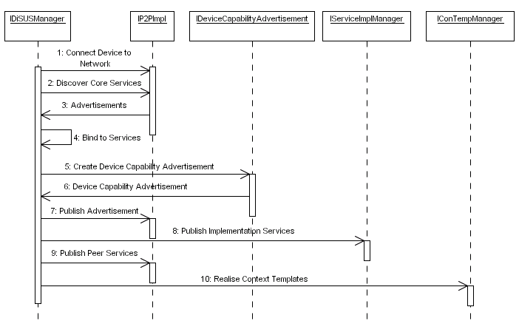
Figure 1 Start Device

Issues
The issues associated with the Sequence Diagram are not known at this stage.

Assumptions
The assumption within this Sequence Diagram is that Public Key infrastructures and Digital Certificates are used for authentication and data encryption and decryption. However the framework provides generic interfaces that allow any security model to be overridden and implemented by device manufacturers.

Scenario/Steps
The DiSUS Manger begins by connecting the device to the P2P network. Once the device has been connected the DiSUS Manager discovers all the Core Services used within the framework using the P2P implementation – these Core Services may be provided by the device itself or remotely by other devices within the P2P network. Once the Core Services have been discovered the DiSUS Manager binds to the endpoint associated with each service. The DiSUS Manager then creates the Device Capability Advertisement and publishes it locally and remotely within the P2P network. The DiSUS Manager then publishes all the implementation services using the Service Implementation Manager. Once the implementation services have been published the DiSUS Manager publishes all the Application Specific Peer Services and realises all the Context Templates the devices supports.

Extensions
This framework provides a level of flexibility that allows Peer Services to form an abstraction that maps to any implementation service technology the device manufacturer or organisation uses. However there may be instances whereby only the Peer Service can be used. For example such service technologies as Web Services and RMI are transactional and although this may not pose a problem in some situations it may in others – one example may be streaming large amounts of video and audio data. In this instance the action is not transactional – data streams need to be opened and maintained whilst the data is being transferred or broadcasted. Therefore it may be easier to stream the data directly to a Peer Service without using a secondary implementation service. This scenario is not set in concrete and device manufacturers may decide to stream data to an implementation service via a Peer Service in order to maintain the level of abstraction.
Provisions need to be made that describes how the Context Templates are managed. It is highly likely that services will unexpectedly become unavailable for a variety of reasons, the most obvious being the device disconnects from the P2P network, taking all the services it provides with it.

References

